

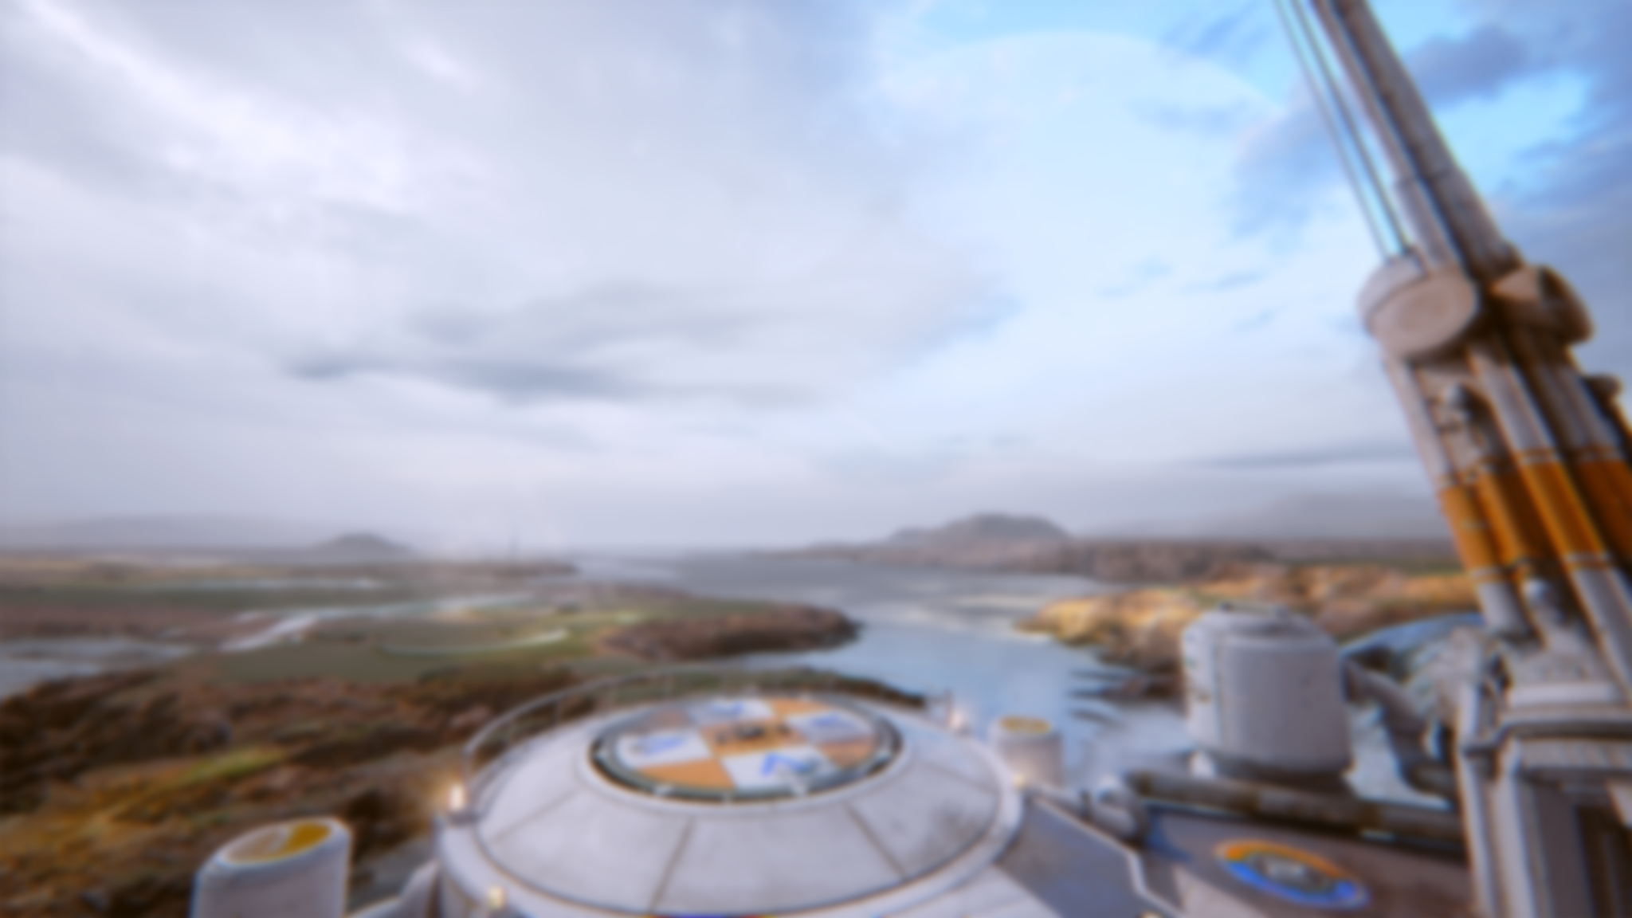

SEMESTER 2
ASSESSMENT
Module title: Advanced 3D Games Engines & Scripting
Module code: GAME50180

Tutors: | Aaron Ketteringham  Room: L105  Aaron.Ketteringham@staffs.ac.uk  +44(0) 1782 294191 (ext. 4191) | Vivian Murray  Room: L105  Vivian.Murray@staffs.ac.uk  +44 (0)1782 294190 (ext.) 4190
 | Adam Martin  adam.martin@staffs.ac.uk | Scott Billyeald-Doughty  S.Billyeald-Doughty@staffs.ac.uk
Bradley Austin
Digital Institute London
Bradley.Austin@staffs.ac.uk
+44 (0)7831 111640

Semester 2 Assignment
Deadline: Friday 23rd April 5:00pm

You will be creating a Team-based game mode within a provided framework. This semesters content will focus on creating and managing game modes within Unreal. You are expected to show of your skills through implementing a fully functional team-based game mode with win/loss or draw conditions.

Existing game modes are vast and include but aren’t limited to:

- VALORANT – Bomb planting, Spike Rush.
- Overwatch – Two Capture Point, Payload, Hybrid.
- Call of Duty – Domination, CTF, DTM, etc.

During semester 2 you will learn how to make Game Modes and develop key game play management skills. Areas we will look at:
- Creating and using Game Modes in Unreal.
- Managing players and Teams.
- The Observer Pattern.
- AI with Behavior Trees.
- Gameplay Assets & Vectors

Your work will build upon the concepts and techniques that we covered in Level 4 and last semester. We expect techniques used last semester to be implemented where applicable in this Semesters work. E.g. interfaces, inheritance, etc.
We will provide the core fundamentals and techniques used in games. You are expected to adapt these fundamentals to your own projects and undertake any additional research and development required. Provide evidence of researching other systems within games on the forums.

You will be provided a framework within which to build your game modes.

You cannot gain marks for simply copying a tutorial online, but if you add in your own code and make enough changes, we will award marks for that. You can use online tutorials as part of your submission, if they are referenced clearly in your forum thread.
While you largely have creative control over what you create, there are a few simple rules we have in place to ensure the quality of the work is high and we can assess all work fairly.
These are:
- If you wish to import assets, please only import the individual ones that you require. Do not inject large asset packs from the Epic Marketplace.
- Your project must work completely from pressing the ‘Play’ button within the editor.
- There should be no warnings or errors in your Blueprints.
This is a prototype. But that doesn’t mean no polish; this means no print strings, ‘lighting needs to be rebuilt’, a proper UI to explain what is happening to the player and a coherent experience. The prototype should be playable to get a feel for the actual game would be like.
Forum Thread
As part of your development you’re required to keep track of your progress on the Digital Academy forum. This forum should be started in Semester 1, Week 1 and be updated weekly.

Last name, first name – username
For example: “Ketteringham, Aaron – K007000c”
You should reply to your own thread, adding more information as required. Please do not reply to other people’s threads.
All posts you make must be presented professionally. They must reflect the quality that is expected at university. They should be spellchecked, have enough content, show clear progression of your work and be of a high-quality nature.
Your posts should include the following information:
- Problems you’ve tackled, solutions you’ve implemented. You can use tutorials as a starting point, but it is far better than you make something simple that you understand than something complex that you do not.
- Small videos of development work. These should be short clips of your prototype whether it’s working or not.
- What you have done so far.
- Any research for the areas you will be tackling. This will mostly be links to online content you have found, such as documentation, forum posts and tutorials you have found useful.
- What things have you discovered during the development of your assets.
- Screenshots of your work embedded into the posts, so they do not need to be clicked or downloaded.
- Any Blueprint ideas / development progress of these.
- Changes you have made since the last post.
- What changes you plan to make in the next week.
- Long term future development plans.
- If you have done any testing with friends, what was the result of this.
Your posts should not include:
- Stating what you have learnt from lessons (but do show us how you’ve used the content to create your own content).
- Content copied from tutorials – unless you’re referencing it clearly.
- Any images that need to be clicked or downloaded to be viewed.
- Requests for support, please use the official email channels.
- Memes or anything not directly related to your work.

Please do not post links to images, instead, embed the actual image on the post. You can use websites such as imgur to host them externally if needed. You could also post embedded videos via YouTube of your progress.

To do this quickly and effectively we recommend using ShareX, a free application that lets you quickly snip areas of your screen as images or video clips.

You could also use the built-in Windows Snipping Tool to snip areas of your screen, although ShareX includes much better functionality (especially for videos).

Project Submission
You are required to submit a UE4 project that includes all the elements listed in the marking criteria. You should delete the logs, intermediate and build directories if they are present in the project before uploading.
You should use 7zip to compress the project into either a zip or a 7zip (7z). No other formats are accepted (including rar).
Semester 2 - Assessment Criteria

Documentation [15%]
- Forums [15%]
  - Break downs of logical problems, Game Modes, development progress, videos, discussion on similar games, debugging should also be shown. See Forum Thread section for more details.
  - Development posts must be staggered throughout the semester.

Final Product [85%]

- Functional prototype [30%]
  - The Game Mode(s) revolves around Teams (PvP or PvE) and has a completable game loop with a win/loss or draw condition if applicable.
  - The prototype should be playable; No bugs, no print strings, no having to open blueprint to change settings.
  - There is consideration for player feel and gameplay.
  - UI to communicate game mode information to the player and the inclusion of a menu to select typical game mode options.
    - Scores, tutorial text, gameplay information, etc.
    - Number of players, Game Mode, map, etc.
  - The user interface is presented in neat and informative manner.

- Scripting quality & Complexity [40%]
  - The Game Mode(s) should be functional, include standard practices taught and contain logical solutions for dealing with game mode related problems; Events, spawning teams, initialization chains, respawns, etc.
  - Additional entities are included that support the game play or Game Mode(s) and are set up correctly; Managers, gameplay assets, levels. This also includes the use of AI entities and Unreals Behaviour trees.
  - Game Mode UI is constructed well and scripted to a good standard.
    - Score, timers, game mode selection/map selection, etc.
  - Consideration of complexity will be made based on the prototype; Higher complex prototypes will include more complex rules, game play or multiple game modes.

- Presentation of prototype [15%]
  - Final Presentation video of what you’ve made over the 12 weeks and an executable version.
    - Your required to include a short video demonstrating what you’ve created in the 12 weeks. This video should include voice over while you play the prototype discussing key aspects, problems you’ve had and solutions you’ve included. We do not need to see your blueprints; we will see these after hand in.
    - Link your video into the forum and make sure it’s ‘public’ or ‘unlisted’.
      - Videos set as private will not be marked.

Additional Tips & Information

Backing up
You must always keep a backup of your work. It is strongly recommended that you save all work directly to a cloud service like Google Drive, Dropbox, or Microsoft OneDrive.
Never run a project from OneDrive, pen drive or external, this can corrupt your project and OneDrive will not save a project run from the cloud. Save your project, close it, zip it, then put it on OneDrive. To work on it download the Zip, Unzip, and start working.

Naming your assets
Important: It is very important that you never rename assets outside of the Unreal Engine. If you do this, it is likely to break, and you will need to restore it from a backup. This stands true for all assets, not just Blueprints and maps. You should also never use any special characters in your asset names.

How do I hand in my work when it is completed? How do I access the DIS?
You will be handing in your work through the Digital Academy Uploads (DAU). A link to the DAU will be on Blackboard or found through the Digital Academy Portal.
You will have to log in using your student id and password, find the correct module and submission and upload your work.

Can I submit my work from home?
Yes, however this is TOTALLY UNSUPPORTED and we recommend that you submit on campus with a university computer.

Can I have an extension please?
The only time that you will be granted an extension for this module is if you have a learning support agreement (LSA), in this instance you will need to contact a module lecturer.

Extensions
Extensions can only be granted based on a learning support agreement (LSA). If you are entitled to an extension in accordance with your LSA, please contact a module lecturer or the module leader to discuss extended deadlines:

Aaron Ketteringham – Module Leader
Contact email: aaron.Ketteringham@staffs.ac.uk

Other modules tutors’ emails can be found on at the top of this document.

If you are unable to meet the submission deadline for your work due to difficulties beyond your control e.g. personal illness or personal difficulties. If you find yourself in such a position you can make a claim for exceptional circumstances. EC (Exceptional Circumstances) claim.

